**PRESS RELEASE**

**FOR IMMEDIATE RELEASE**

**Satay and Soto Become Favorites in Malaysian Peninsula**

Kuala Lumpur, Kominfo Newsroom - Satay and soto are culinary specialties that are generally acceptable and are favorites among people in Malaysian Peninsula.

Indonesian citizen from Jakarta, Ikhwanul, who works for a United States multinational company in Kuala Lumpur, Tuesday, 18 April 2023, said satay is a dish that is loved by all people in Malaysia.

According to him, one of the favorite places for Indonesian citizens and Malaysians to enjoy satay, especially around Kuala Lumpur, is Warung Sate Bu Leha, which is located in Petaling Jaya, Selangor. This place has been selling Madura satay for around 15 years.

“This place is very well-known among Indonesians. Many students also go there. Those who come are not only Indonesians but also Malaysians," said Ikhwanul.

Sate, which is usually called "satay" in Malaysia and Singapore, is not only available in Indonesia but also in Singapore, Malaysia, Thailand, and Brunei Darussalam.

In Malaysia, many restaurants are selling various variants of satay, such as Satay ayam (chicken satay), satay kambing (mutton satay), and satay sapi (beef satay). Usually, this satay is served with peanut sauce. There is also a satay padang variant that is sold in Padang restaurants.

An Indonesian citizen from West Sumatra, Wiffy Zalina Putri, who has lived in Malaysia since she was still in the fifth grade of the elementary school said that ketupat (rice cakes) and sate padang sauce are a must for Eid al-Fitr.

Sate is also a menu served during Iftar Nusantara program in a hotel in Kuala Lumpur. Senior General Manager of Sunway Hotels and Resorts Wilfred Yeo Cha said that the menu served would alternate between the Malaysian and Indonesian versions of satay.

The common types of satay available in Malaysia include Satay ayam (chicken satay), satay kambing (mutton satay), and satay perut (beef intestine). Malaysian satay is often accompanied with a type of rice cake called Impit (lontong) and cucumber slices.

For iftar they also offer soto betawi which is served with beef, fried potatoes, tomatoes, and celery, accompanied with emping (nut crackers) and lime juice. Soto betawi is one of the special dishes because, according to Consultant Chef Sunway Putra Hotel Chew Teik Chye, the fresh spices used are processed in such a way as to bring out the authentic taste.

Chew said the process to make sure the taste would be the same as the original Soto Betawi taste is quite long and through several repetitions. The sweet soy sauce used comes from Indonesia.

Soto is also a much-loved culinary dish, it is evidenced by the various types of soto sold and many soto stalls open on the Peninsula. It is served in various ways, some are served with white rice, impit (lontong), or noodles like in Johor and Singapore.

Various culinary delights that are shared by people in ASEAN Member States are one of the glues for international relations, as well as an encouragement to make the region a center of world growth as the theme of the 2023 ASEAN Indonesia Chairmanship.

Of course, it's not only satay and soto, typical dishes that are favorites among people in the ASEAN Member States. Nasi lemak, rendang, lemang, somtam, laksa, pad thai, fried rice, gado-gado, meatballs, tomyam, pho and banh mi, amok fish, balut, and many other culinary delights are also the favorites and identities of the people in ASEAN. (Virna/Elvira/TR)

***

For more information, please contact:

**Director General of Public Information and Communications of the Ministry of Communications and Informatics – Usman Kansong (0816785320).**

Get other information at <https://infopublik.id>

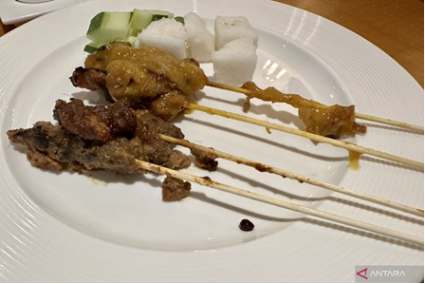

Satay served during iftar at a hotel in Kuala Lumpur, Malaysia, Friday, 17 April 2023. (ANTARA/Virna P Setyorini)